**TAKE YOUR CHILD TO THE LIBRARY DAYS!**

**Saturdays, February 12 & 19, 2022**

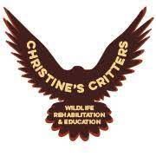

**BIRDS OF PREY ZOOM PROGRAMS**

**With Connecticut Falconer & Wildlife Rehabilitator**

**Christine Peyreigne from CHRISTINE’S CRITTERS**

# *Saturday, February 12th @ 10:00am – Compare HAWKS, FALCONS & OWLS with Christine’s live animal ambassadors & hear the story of *Maggie the One-Eyed Peregrine Falcon: A True Story of Rescue & Rehabilitation.*

# https://ctland.org/wp-content/uploads/2020/05/Bird-Banner.png

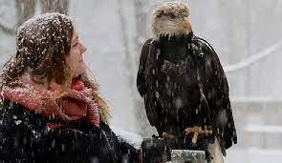*Saturday, February 19th @ 10:00am – Learn about BALD EAGLES with Christine’s Eagle ambassadors Aurora & Aquila! Enjoy the story *On Eagle Cove* about a young birder & her mother experiencing the majesty of an eagle aerial show.

**Stop in our libraries for other fun activities!**

**9:00am – 3:00pm**

Visit Christine’s **family friendly** videos on Tik Tok at

**Christine’s Critters**

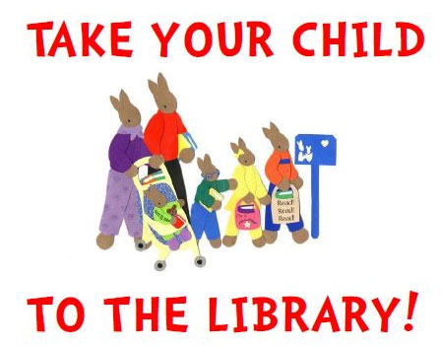

*PLEASE SIGN-UP ONLINE OR CALL

nbranfordlibraries.org

Atwater – 203-315-6020

Edward Smith – 203-484-0469