**TAKE YOUR CHILD TO**

**THE LIBRARY DAY!**

Celebrate with our Birds of Prey Programs

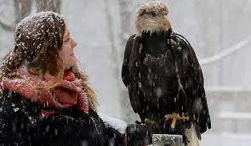 (Christine’s Critters), a Birds of Prey

Take & Make Craft Bag (1 per visiting

child; pick-up in children’s room), our many

books and a Birds of Prey

I Spy in the children’s Room.

------------------------------------------------------------------------------------------

**BIRDS OF PREY ZOOM PROGRAMS with**

**CHRISTINE’S CRITTERS** (sign-up online or call)

*Saturday, February 12th @ 10:00am – Compare HAWKS, FALCONS

& OWLS with Christine’s live animal ambassadors & hear the story of *Maggie the One-Eyed Peregrine Falcon: A True Story of Rescue & Rehabilitation!*

*Saturday, February 19th @ 10:00am – Learn about BALD EAGLES

with Christine’s Eagle ambassadors Aurora & Aquila!Enjoy the story *On Eagle Cove* about a young birder & her mother experiencing the majesty of an eagle aerial show.

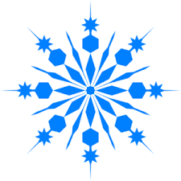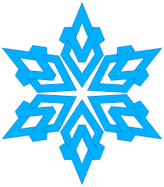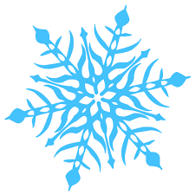

**Saturdays,**

**February 12 & 19, 2022**

**Stop in for other fun activities!**

**9:00am – 3:00pm**











*GIVE THE GIFT OF READING, LEARNING & FUN:

GET YOUR CHILD A LIBRARY CARD!*

*Just bring along YOUR ID or a bill (noting your current address). If you do not have a license or bill with a current address, please call us and we can discuss other options for getting your child a library card.













North Branford Public Libraries:

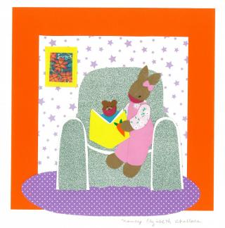Atwater Memorial ~ 1720 Foxon Rd., N. Branford, 203-315-6020

Edward Smith ~ 3 Old Post Rd., Northford, 203-484-0469

[www.nbranfordlibraries.org](http://www.nbranfordlibraries.org)

YOUR LIBRARY